Adaptive control HW1

B0252103 機械四 呂恩暄

2.

(a) (b)

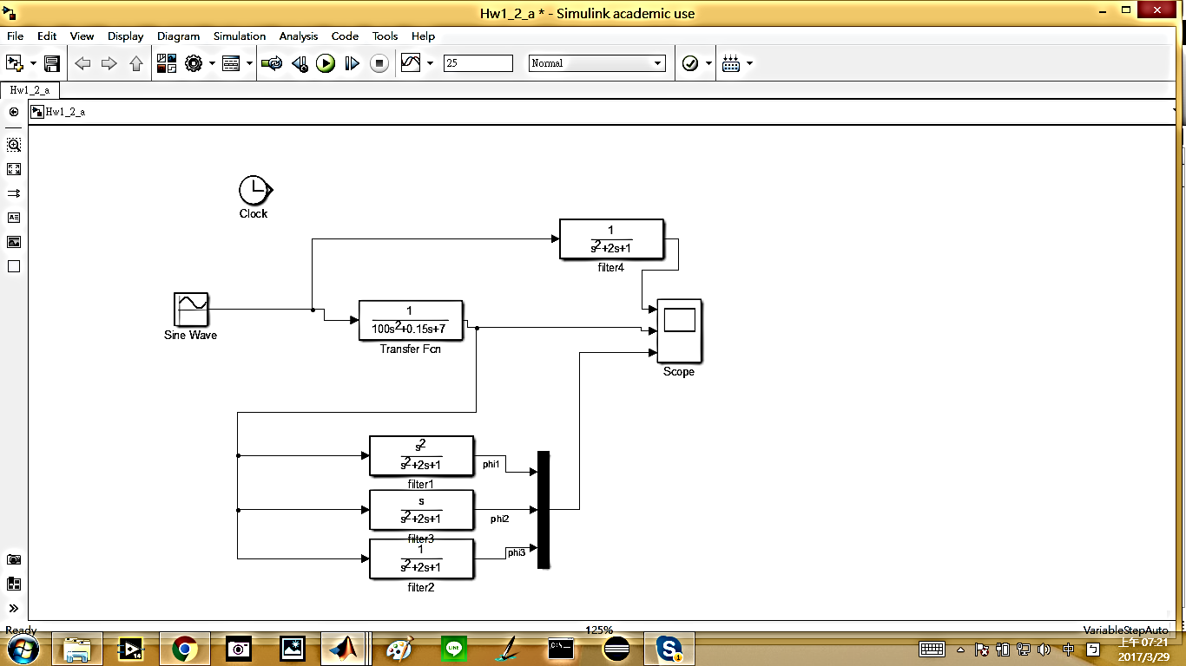 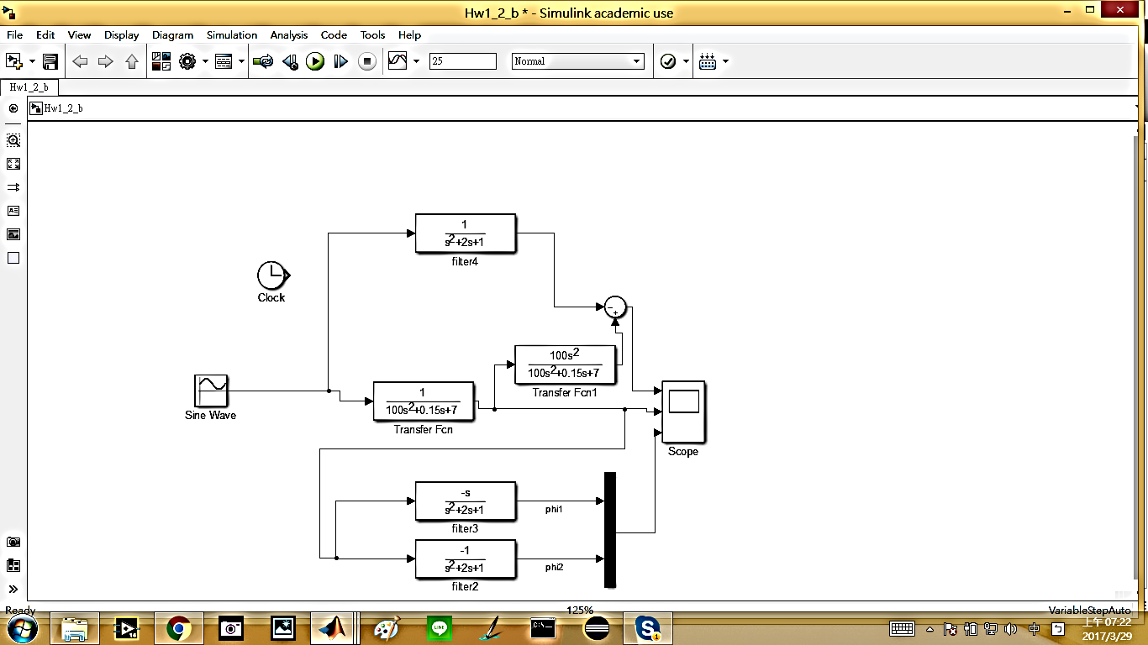

Ans:

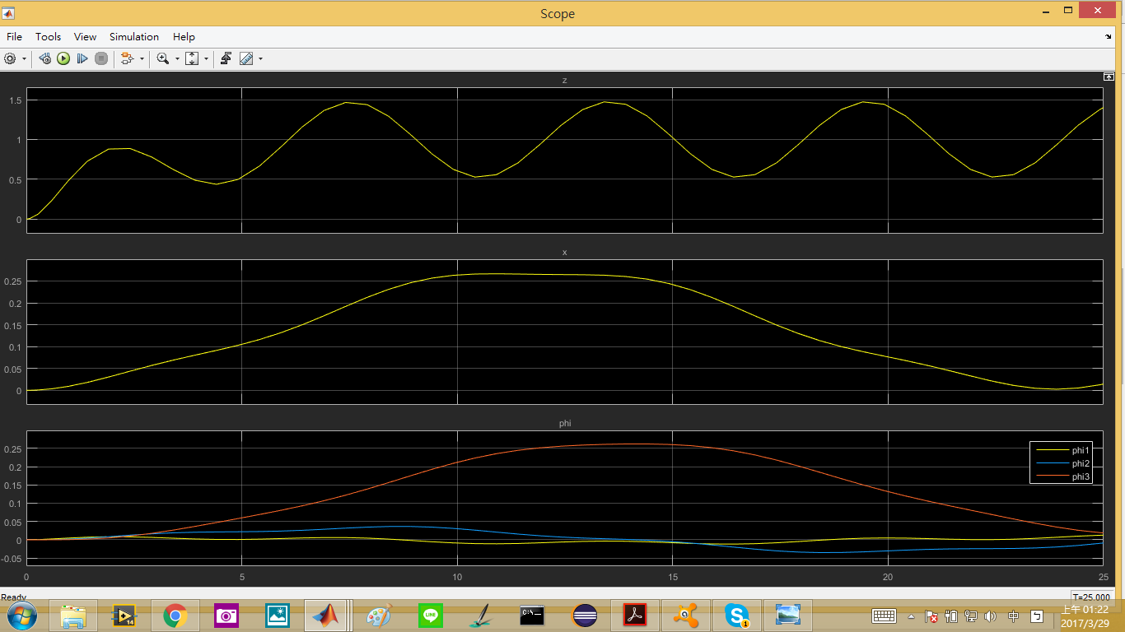 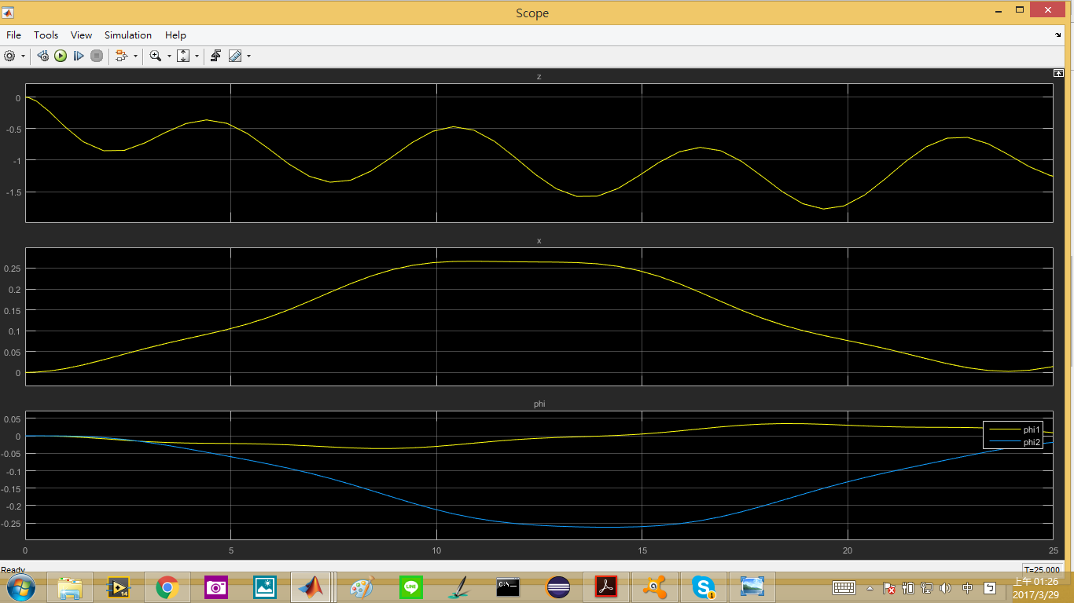

  
   
    

From the above two figures, we can notice that because the PMs are chosen differently, therefore, z, are shown in different form. However, since the input and the plant is the same, thus, the output, x, and phi (known parameters and measurable signals) are basically the same with only sign difference.

\*parameter estimation

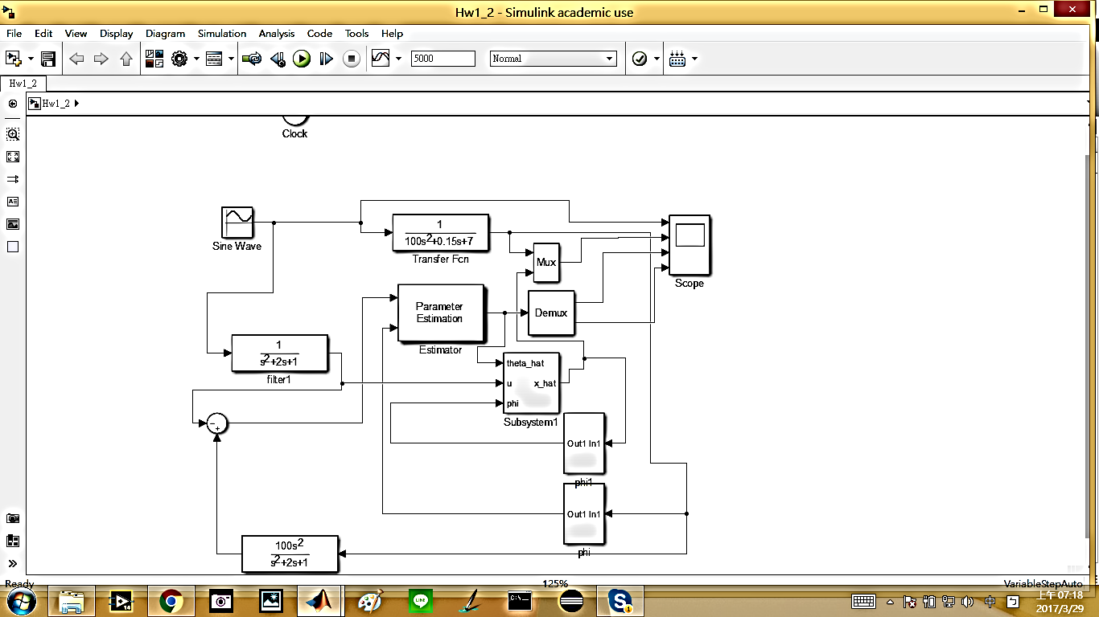

250 s

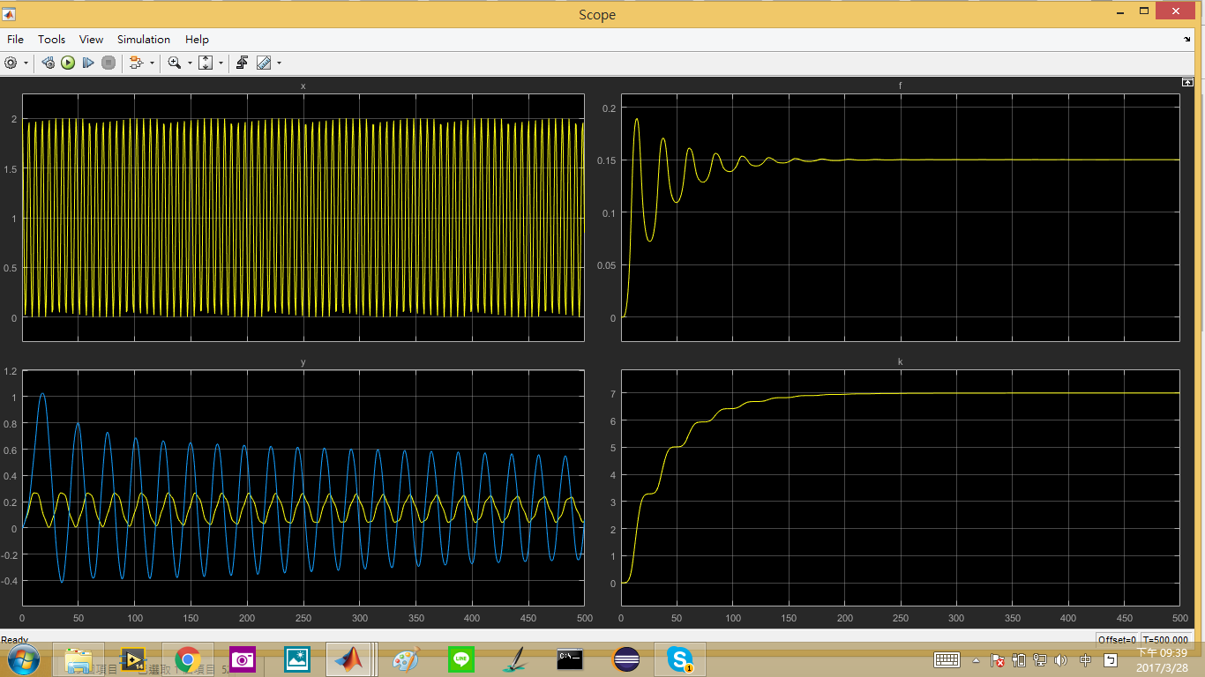

5000 s

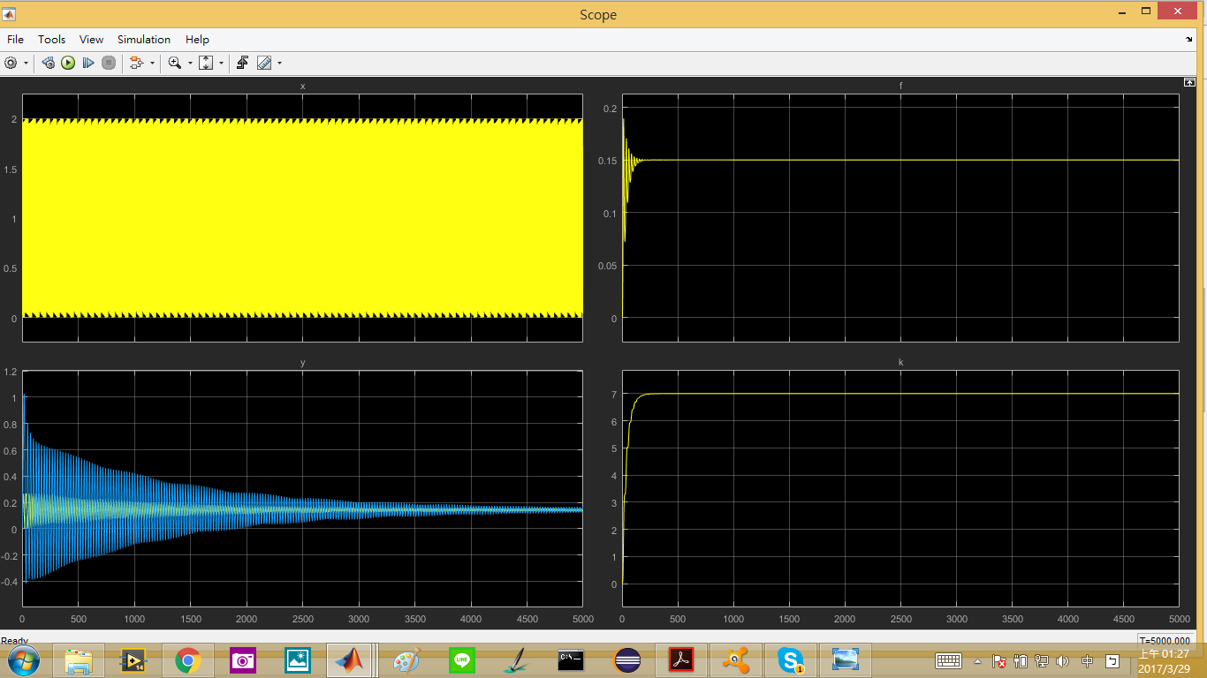

PM:

  
  

Aside from model output simulation, the parameter estimation has also been done in addition. From the two scope above we can see that f and k all converge to the real value in a relatively fast speed (200s). However, output simulation based on the estimated plant converges in a very slow speed (5000s). The adaptive law that we used in this homework, gradient law, is the most basic method with limited performance. Therefore a better adaptive law is needed in order to improve the converging time and make the result of parameter estimation be reliable.

4.

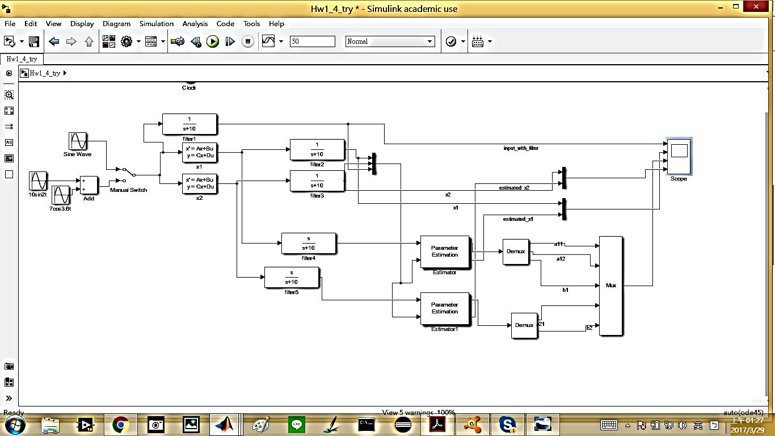



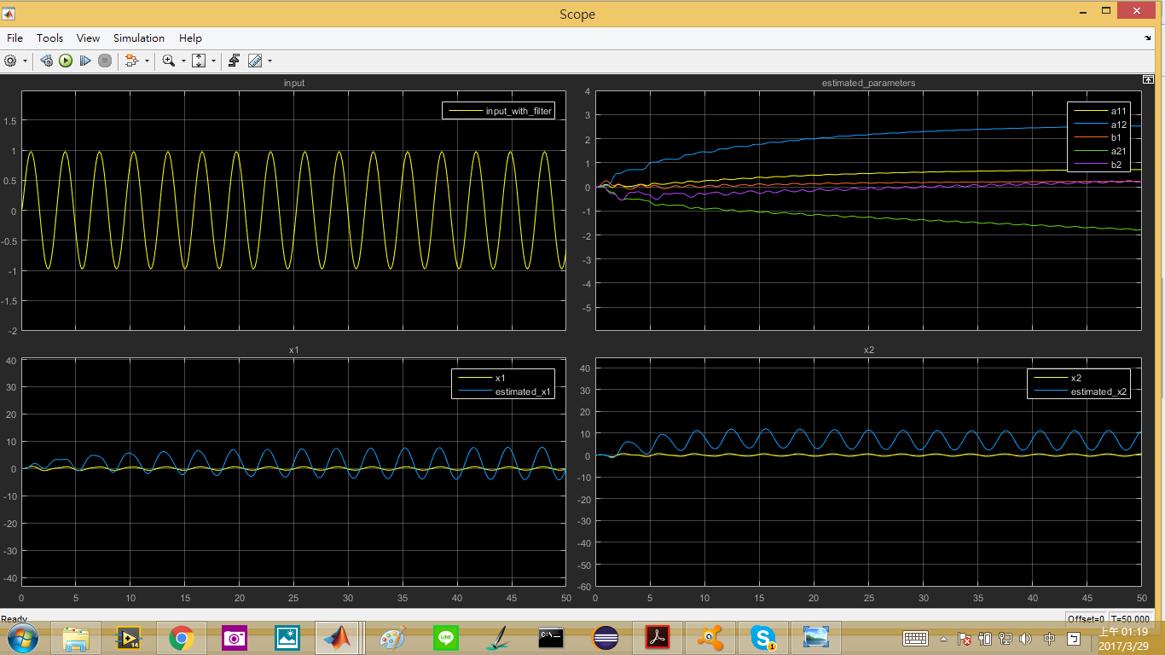



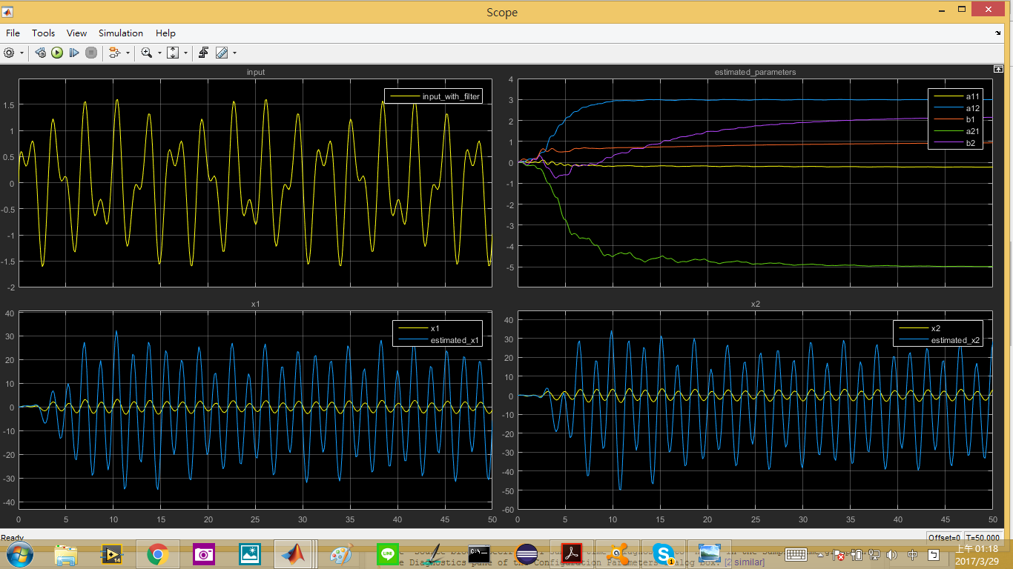

PM

  

Comparing the two scope above we can see that different input signal, u, will gave different effect in parameter estimation. For the first signal

,

several parameter estimation failed. However, for the second one

,

parameter estimation can all converge. The reason of this is because the different richness of the input signal. The phi in this problem has the degree of 3, therefore, the input signal need to contain at least 2 distinct nonzero frequencies. The first input is not SR and the second one is SR in this problem.